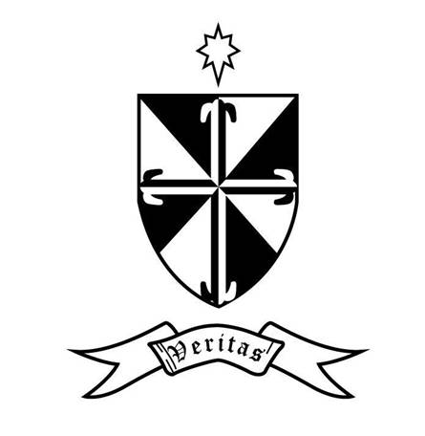
Dominican College Muckross Park

Motto: VERITAS

VISION AND MISSION STATEMENT

‘Be who God meant you to be and you will set the world on fire’.
Catherine of Siena

Our Vision

As a school in the Catholic, Dominican tradition, our educational vision as expressed in our motto, Veritas, encompasses the lifelong search for truth, respect for tradition, and commitment to human flourishing.

Our Mission

We are proud of our lived Christian heritage, which inspires us to welcome and respect people of all backgrounds and beliefs. We tailor our educational approach to the needs of each individual student. We aim to excel in teaching and learning and provide an extensive programme of additional activities as we believe that every student deserves the opportunity to flourish.
Sustained by our Dominican tradition, we invite our students to engage with the values of Jesus Christ, who is the Way, the Truth and the Life. Our educational community cultivates care in our students and staff for themselves, their neighbours, and their planet. We aim to strengthen empathy, nurture integrity and discernment, and generate a love of lifelong learning throughout our school community.

